BSCS FINAL PROJECT
Design and Test Specification

COLLABRYX



Project Advisor

Irfan Latif

Presented by:
Group ID: F25CS072

Student Reg# Student Name
L1F22BSCS0693 Ahsan Ali
L1F22BSCS0456 Zain-ur-Rehman
L1F22BSCS00683 Affan Ahmer

Faculty of Information Technology & Computer Science

University of Central Punjab
Design and Test Specification
SDP Phase III

COLLABRYX
Advisor: Mr. IRFAN LATIF

Team # F25CS072
Member Name | Primary Responsibility
AHSAN ALI | AI Module development and deployment
AFFAN AHMER | Frontend Development
ZAIN UR REHMAN | Backend development and deployment

Table of Contents
Table of Contents i
Previous Phases Feedback ii
Abstract 1
1. Introduction 2
1.1 Product 2
1.2 Background 3
1.3 Objective(s)/Aim(s)/Target(s) 4
1.4 Scope 4
1.5 Business Goals 5
1.6 Document Conventions 5
2. Technical Architecture 6
2.1 Application and Data Architecture 8
2.2 Component Interactions and Collaborations 10
2.3 Design Reuse and Design Patterns 13
2.4 Technology Architecture 13
2.5 Architecture Evaluation 14
2.5.1 Reasons for Infrastructure and Technology Selection: 14
2.5.2 Pros and Cons of the Selected Technology: 14
3. Detailed Component Design 15
3.1.1 Design Principles Followed 15
3.2 Component-Component Interface 16
3.2.1 Post Generation Sequence 18
3.2.2 Match Generation Sequence 19
3.2.3 Connection Acceptance Sequence 20
3.3 Component-External Entities Interface 21
3.4 Component-Human Interface 25
3.4.1 HCI Norms Followed 26
3.4.2 Input Validation Points 28
3.4.3 Feedback Mechanisms 29
4. Screenshots/Prototype 30
4.1 Workflow 30
4.1.1 High-Level Workflow Overview 30
4.1.2 Registration and Onboarding Workflow 32
4.1.3 AI Matching and Connection Workflow 33
4.1.4 Post Creation and Content Moderation Workflow 34
4.1.5 Reaction and Comment Cascade Workflow 35
4.1.6 Real Time Messaging Workflow 36
4.1.7 AI Mentor Workflow 37
4.1.8 Feed Personalization with Thompson Sampling Workflow 38
4.1.9 System State Diagram 39
4.2 Screens 40
4.2.1 Landing page 40
4.2.2 Dashboard 48
4.2.3 Smart Matches 48
4.2.4 Messages 49
4.2.5 Requests 49
4.2.6 AI Mentor 50
4.2.7 My Profile 50
4.2.8 Settings 51
5. Other Design Details 51
6. Test Specification and Results 52
6.1 TC-001 User Registration 52
6.2 TC-002 User Login with Email 52
6.3 TC-003 User Login with Invalid Credentials 53
6.4 TC-004 Account Lockout After Multiple Failed Logins 53
6.5 TC-005 Five Step Onboarding Completion 54
6.6 TC-006 Create a Post 55
6.7 TC-007 Add Reaction to a Post 56
6.8 TC-008 Add Threaded Comment 56
6.9 TC-009 Send Connection Request 57
6.10 TC-010 Accept Connection Request 58
6.11 TC-011 Send Real Time Message 58
6.12 TC-012 Generate AI Matches 59
6.13 TC-013 Circuit Breaker Protects Worker on Failure 60
6.14 TC-014 AI Mentor Chat with RAG Context 61
6.15 TC-015 AI Provider Fallback on Primary Failure 62
6.16 TC-016 Content Moderation Auto Approve 63
6.17 TC-017 Content Moderation Auto Reject 63
6.18 TC-018 Content Moderation Keyword Fallback 64
6.19 TC-019 Personalized Feed Ranking 65
6.20 TC-020 Optimistic Locking Prevents Lost Updates 66
6.21 TC-021 Row Level Security Prevents Cross User Data Access 66
6.22 TC-022 Zod Validation Rejects Malformed Input 67
6.23 TC-023 CSRF Token Validation on File Upload 68
6.24 TC-024 Rate Limiting on Auth Endpoint 68
6.25 TC-025 Embedding Dead Letter Queue Retry 69
6.26 TC-026 Notification Generation on Connection Request 70
6.27 Table 6.27: TC-027 Cache Clearing on Sign Out 70
6.28 TC-028 Password Reset Flow 71
6.29 TC-029 Block User 72
6.30 TC-030 Health Check Endpoint 73
7. Summary of Test 74
8. Revised Project Plan 75
9. References 76
Appendix A: Glossary 77
Appendix B: IV & V Report 78

Previous Phases Feedback

Idea Defence Feedback (Screenshot)

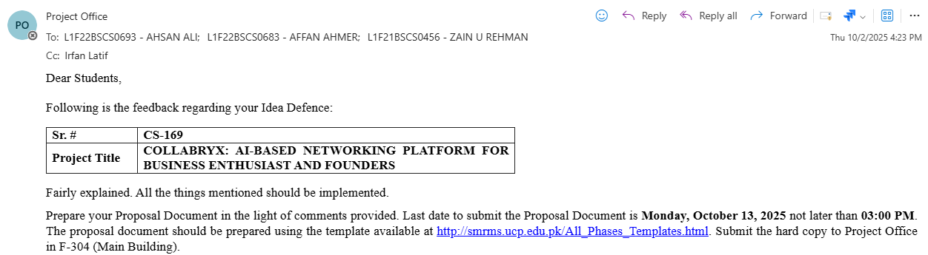

Phase 2 (SDS) Feedback (Screenshot)

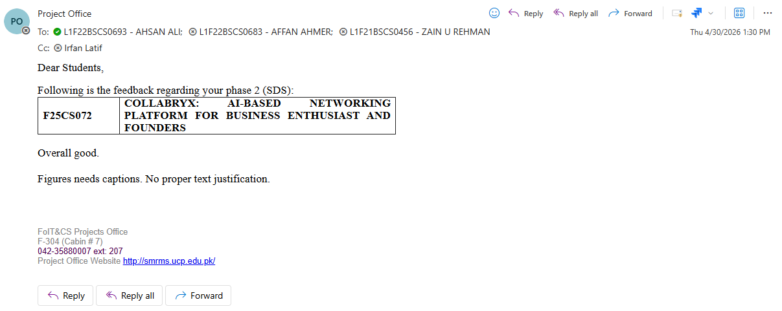

Abstract
Collabryx is an AI-assisted collaborative web platform that helps users discover compatible collaborators through semantic profile matching (vector embeddings and similarity search), supports real-time interaction via messaging and notifications, and presents a modern, responsive interface—including interactive 3D visuals—built on Next.js, React, TypeScript, Supabase (PostgreSQL with RLS), and supporting Python services for embeddings, matching, and related backend tasks.

Security and reliability are handled through layered controls such as row-level security, input validation and sanitization, CSRF protection, and rate limiting, aiming for a production-quality system suitable for team formation and ongoing collaboration.

Introduction
Collabryx is a web-based platform that helps professionals find the right people to work with. Instead of scrolling through profiles and sending cold messages hoping for a reply, the platform uses artificial intelligence to study each person's skills, experience, and interests and then suggests who they should connect with. It was built for anyone looking for a co-founder, a teammate for a project, help building an MVP, or a partner for school work. The entire platform was built using Next.js, React, TypeScript, and Supabase, with a Python backend running all the AI tasks.
The core of the platform is the AI matching engine. When a user fills out their profile and completes a five-step onboarding process, the system creates a unique digital fingerprint of their professional identity using a technique called vector embeddings. This fingerprint is a mathematical representation of who they are based on their skills, work experience, interests, and what kind of collaboration they are looking for. Every time a profile is updated or a new user joins, the system compares every profile against every other profile using a similarity search. The results are ranked across four factors including how similar their professional backgrounds are, how much their skills overlap, what shared interests they have, and how active they are on the platform. Each match comes with a percentage score and a plain English explanation of why two people would work well together.
Beyond matching, the platform includes a full set of collaboration tools. Users can create posts about projects they are working on or people they need to find, with support for images and videos. Other users can react to these posts with emojis and leave threaded comments that support nested replies. There is a real time messaging system powered by WebSocket connections that shows when someone is typing and when they have read your message. Users can send and accept connection requests, block other users, and manage their privacy settings to control who can see their profile and activity. An AI mentor feature provides a chat assistant that knows the user's full profile and can give personalized advice on finding collaborators, reviewing their profile, or brainstorming project ideas.
The platform was designed with security and reliability as core requirements. All 34 database tables are protected by row level security policies that ensure users can only access their own data. Input validation using Zod runs on every form, every API call, and every search parameter. Rate limiting prevents abuse across six different categories including authentication, file uploads, and AI chat. Failed login attempts trigger account lockout with increasing delays. An immutable audit log records every security relevant action. A circuit breaker pattern prevents the Python AI worker from causing cascading failures if it becomes unresponsive. The result is a platform that makes professional discovery smarter, communication faster, and collaboration more intentional.

Product
Collabryx is a web application that takes the guesswork out of finding the right people to collaborate with. You start by building a detailed profile that captures your skills, work experience, interests, and what kind of collaboration you are looking for whether that is a co-founder, a teammate, a partner for building an MVP, or someone to work on a final year project. Once your profile is set up, the platform's AI engine analyzes your professional identity and compares it against every other user on the platform. It then presents you with a ranked list of potential collaborators, each with a match percentage, an explanation of why you would be a good fit, and a breakdown of what you have in common. You can connect with them directly, dismiss suggestions you are not interested in, or adjust your preferences to refine future recommendations.
The product goes beyond matching with a complete set of tools for collaboration. A social feed lets you post about projects with images and videos, and others can react with emojis or leave threaded comments. A real time messaging system lets you chat instantly with connected users, with typing indicators and read receipts so you know when someone has seen your message. An AI mentor assistant provides on demand advice by pulling your profile context to give personalized suggestions for finding the right collaborators or improving how you present yourself. The platform also includes an analytics dashboard where you can see how many people have viewed your profile, how your posts are performing, and how your network is growing over time.

Background
Professional networking has remained largely unchanged for over a decade. The dominant model asks users to build a profile, list their skills, and then search through a database of other profiles using keywords. If you find someone interesting, you send a message and hope they respond. This approach puts all the effort on the individual. You have to know what you are looking for, know the right search terms to find it, and then initiate contact with someone who may not even be open to connecting. For people looking to collaborate on projects, start companies, or build things together, this process is slow, frustrating, and unreliable.
The problem is especially acute for specific groups. University students working on final year projects often struggle to find teammates with complementary skills. Aspiring founders looking for a co-founder have no way to know who might be a good fit beyond surface level browsing. Developers with an idea for an MVP need to find technical or business partners but have no signal about whether someone is available or interested. The existing platforms treat everyone the same and provide no intelligence about compatibility, availability, or intent to collaborate.
Collabryx is built to solve this specific problem. Instead of requiring users to search and guess, the platform actively analyzes every profile on the system and generates personalized match suggestions. It uses semantic understanding rather than keyword matching to determine compatibility. It surfaces not just who might be a good collaborator, but why they would work well together and what specific areas of overlap exist. The goal was to remove the friction from professional discovery and make finding the right collaborator as simple as reviewing a ranked list of suggestions generated by AI.
The platform was designed from the ground up to handle the full lifecycle of collaboration matching, connecting, communicating, and tracking. It combines vector embedding technology for semantic similarity with traditional structured data for skills and interest overlap. A Python microservice handles all AI workloads including embedding generation, match scoring, feed personalization, and content moderation. The front end is built with Next.js and React, and all data is stored in PostgreSQL with row level security enforced at the database level. The result is a platform that not only helps people find each other but gives them the tools to work together once they do.

Objective(s)/Aim(s)/Target(s)
- Eliminate manual keyword search by automatically analyzing every user and generating ranked match suggestions using vector similarity
- Make every AI match explainable with percentage scores, plain English reasoning, and breakdowns across four weighted factors
- Enable instant communication so users can go from seeing a match suggestion to having a real time conversation in under two clicks
- Deliver a personalized feed for each user using Thompson Sampling that balances engagement with content discovery across four ranking factors
- Protect all user data with row level security on all 34 tables, Zod validation, six tier rate limiting, and an immutable audit log
- Isolate all AI workloads including embeddings, match scoring, and moderation in a dedicated Python microservice with circuit breaker protection
- Support the full collaboration lifecycle from discovery and connection to messaging, posts, analytics, and moderation within a single platform
- Ensure the main application stays fully functional even if the AI worker goes offline through circuit breaker and fallback mechanisms

Scope
User Management
- Email and password registration and login
- Password reset flow
- Profile creation with name, bio, headline, avatar, and location
- Five step onboarding flow for new users
AI Matching
- Profile embedding generation
- Basic similarity search against other users
- Match suggestions displayed
- Basic match preferences
Social Posts
- Create posts with content and post type selection
- Upload images as attachments
- Five emoji reactions
- Comments with nested replies
- Delete own posts
Connection
- Send connection requests
- Accept or decline incoming requests
- Cancel outgoing requests
Messaging
- One on one conversations
- Real time message delivery
AI Mentor
- Chat interface with a profile aware AI assistant
Notifications
- Auto generated notifications for connections, reactions, comments, and messages
- Notification bell with unread count

Business Goals
- Validate that AI powered professional matching has real user demand
- Build a minimal user base of active profiles to test matching quality
- Reduce the time it takes for users to find a relevant collaborator
- Achieve consistent daily engagement through the social feed and messaging
- Establish the platform as a useful tool for students and early career professionals
- Gather feedback on AI match explanations to improve recommendation quality
- Keep operating costs low using free tier Supa-base and open-source AI models
- Lay the groundwork for future features based on real usage data

Document Conventions
Main Headings: Times, 14 pt, Bold
Subheadings: Times New Roman, 12 pt, Bold
Body Text / Content: Times New Roman, 12 pt, Regular
Figures and Tables: Sequentially numbered and labeled (e.g., Figure 2.1, Table 3.1)
Technical Terms and Acronyms: Written in bold when first introduced
References and Citations: Presented in standard format using URLs or publication titles

Technical Architecture
The Collabryx platform utilizes a modern, custom-built architecture designed to replace the initially proposed MERN stack with a highly decoupled, scalable, and AI-centric system. This technical architecture leverages open-source frameworks and managed cloud services to facilitate real-time networking and complex AI processing.
The system architecture addresses several core operational characteristics:
- System Type: The application is a custom-built solution, bypassing Commercial Off-The-Shelf (COTS) software for its primary logic, though it leverages managed APIs and open-source libraries.
- Processing Type: It utilizes a hybrid processing model. Online Transaction Processing (OLTP) is used for real-time messaging and profile updates, while asynchronous background batch processing is used for generating vector embeddings and scoring feeds
- Data Managed: The platform manages relational user demographics, structured skills arrays, real-time chat histories, and 384-dimensional vector embeddings
- Application Architecture: It operates on an event-driven, layered Client/Server architecture
- Programming Languages: The codebase is predominantly written in TypeScript (81.1%) and Python (12.7%), with database logic utilizing PLpgSQL (4.2%)
- Hardware and Hosting: The system is hosted externally using cloud infrastructure. The frontend is deployed on global edge networks (like Vercel), while the database relies on managed cloud services, and the Python worker operates within a Dockerized environment
- Database Platform: The system relies on a Supabase PostgreSQL database, specifically utilizing the pgvector extension for high-dimensional vector similarity searches
- End-User Interface: Users interact with a browser-based, mobile-first responsive web application featuring interactive 3D visualizations and dark mode capabilities
- Network Architecture: The platform is available over the public Internet (WAN), utilizing HTTPS for RESTful interactions and WebSocket-like protocols via Supabase Realtime for live data synchronization

Figure 2-1: High-Level Architecture Diagram

This Figure2-1 illustrates the high-level flow of the Collabryx system. The Next.js client communicates directly with Supabase for data and authentication. Edge functions handle middleware tasks, while heavy AI computations are offloaded to a dedicated Python worker that interfaces with local models and external APIs

Application and Data Architecture
The Collabryx platform divides its responsibilities across three major logical layers. The table below outlines the core application components.

Layer | Component | Description
Presentation Layer | Next.js 16 Client | Browser-based user interface utilizing React 19, Tailwind CSS 4, and shadcn/ui. It manages UI rendering, 3D visual components via Three.js, and client-side routing.
Business Logic Layer | Supabase Edge Functions | Deno-based middleware executing secure server-side logic such as profile syncing, match calculations, and expired data cleanup.
Business Logic Layer | Python FastAPI Worker | A multi-service backend engine handling AI tasks. Key modules include the embedding generator, match generator, AI mentor processor, and feed scorer.

Table 2.1: Major Application Components

Table 2-2 illustrates the major application components of the system, organized into presentation and business logic layers. The presentation layer utilizes a Next.js 16 client for browser-based UI rendering, integrating Three.js for 3D visuals and Tailwind CSS 4 for styling..

Figure 2-2 : Entity Relationship Diagram (ERD)

The Figure 2-3 highlights the core relational structure within the PostgreSQL database. The central PROFILES entity connects to communication tables (MESSAGES, CONNECTIONS) and AI data tables (PROFILE_EMBEDDINGS, MATCH_SCORES).

Figure 2-3 : Class and Component Association Diagram

The Figure 2-4 shows the structural model and class-level associations. The Next.js frontend services interact with the Supa-base backend classes, which in turn delegate heavy processing tasks to the Python worker's distinct service classes
.

Component Interactions and Collaborations
The system relies on asynchronous, event-driven collaborations to prevent blocking operations during heavy AI tasks.

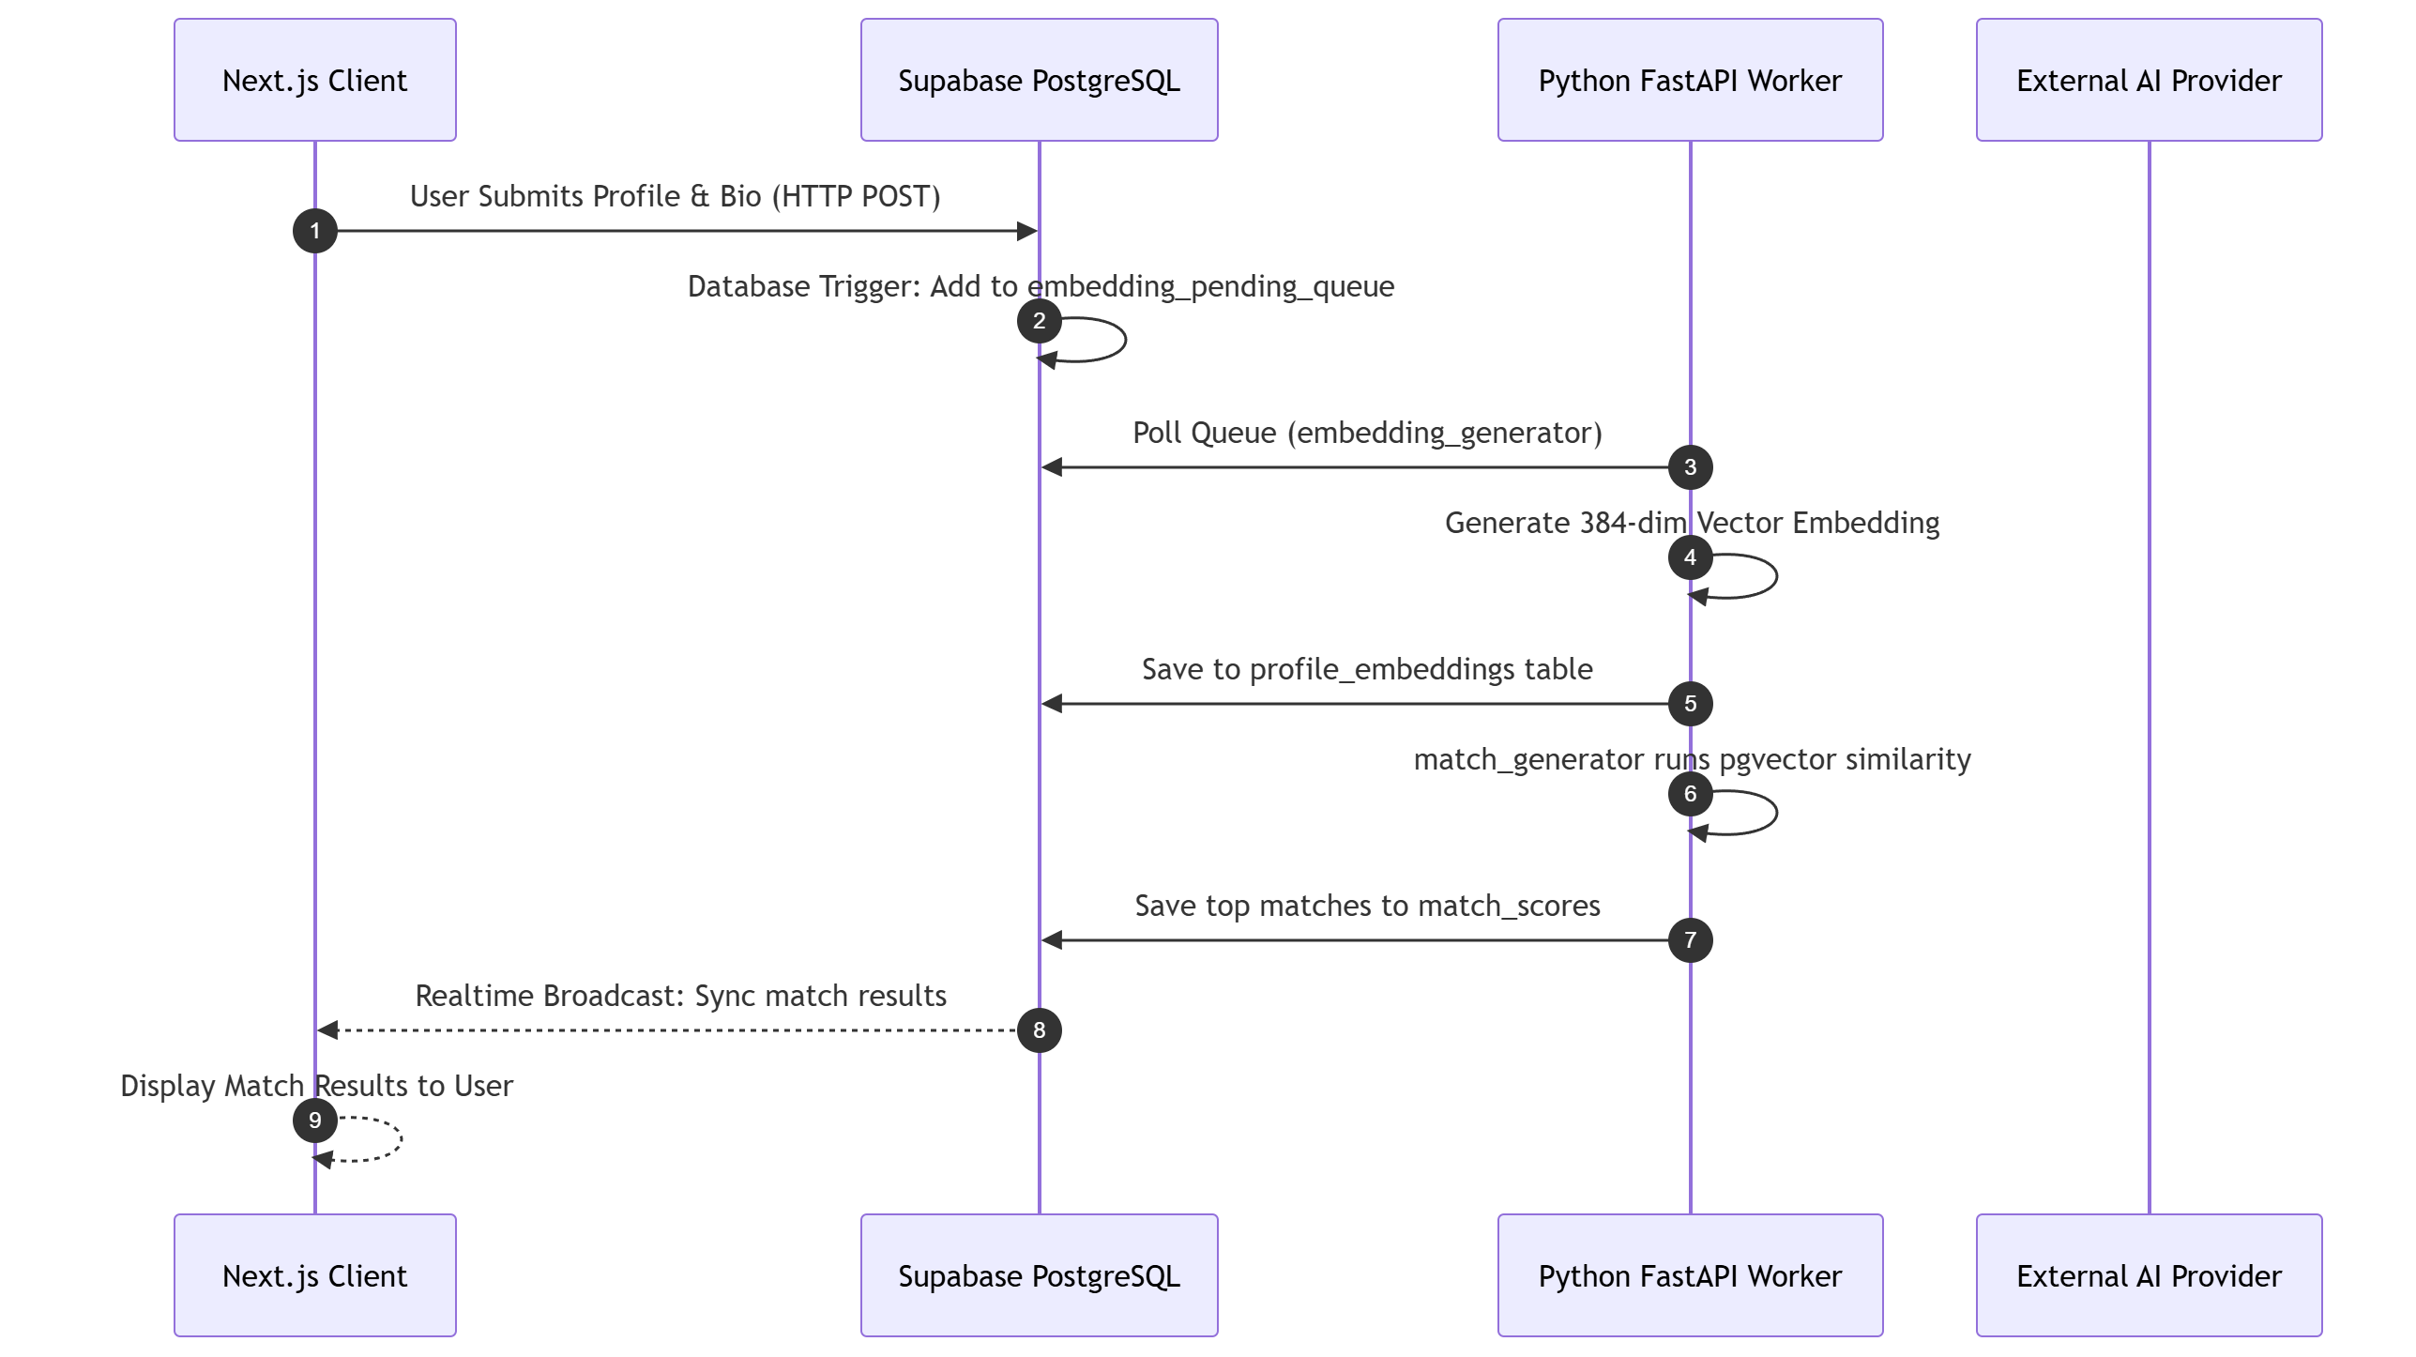
Figure 2-4 : Design Level Sequence Diagram

The Figure 2-5 outlines the user onboarding and AI matchmaking loop. Profile submissions trigger database events, prompting the Python worker to generate vectors asynchronously. Results are saved back to the database and pushed to the client via real-time broadcasting

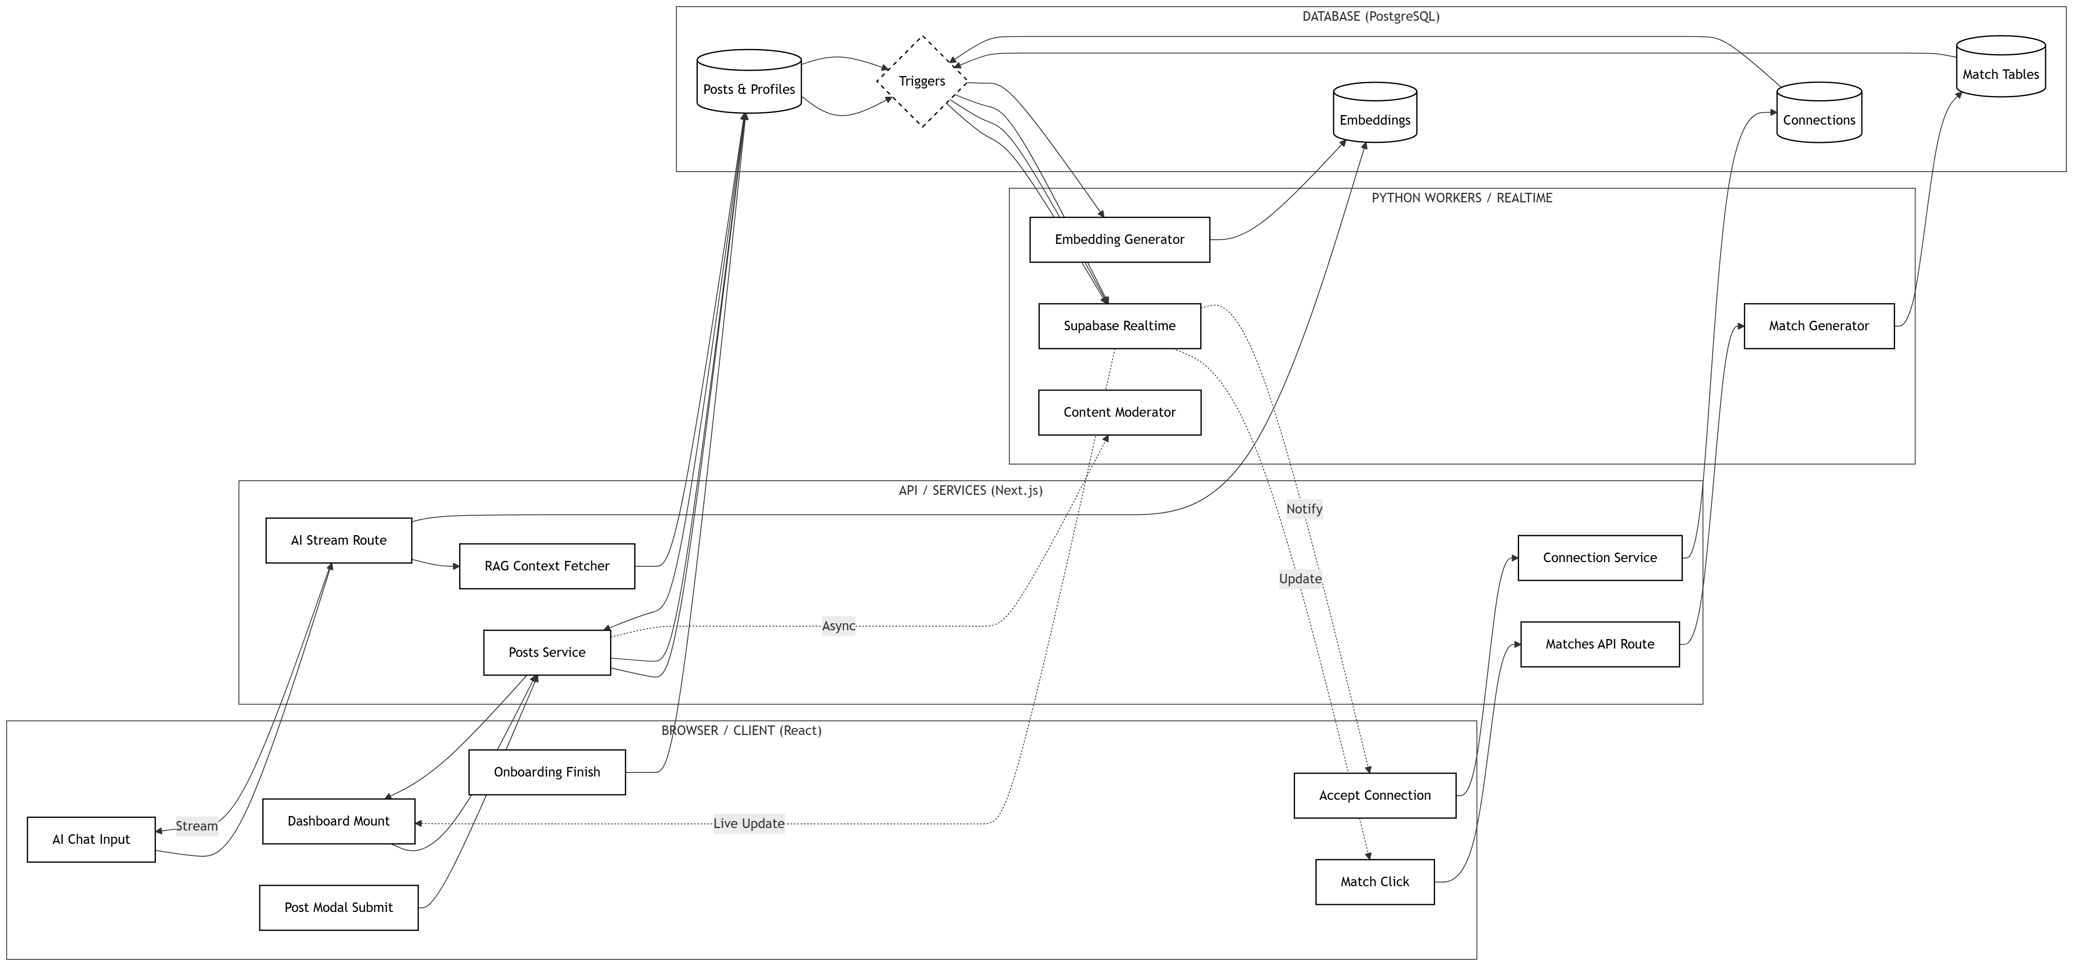

Figure 2-6: Detailed Data Flow Diagram

The Figure 2-6 illustrates the interaction between components during an AI Mentor session. The edge function securely routes the request to the Python processor, which fetches database context, queries the external LLM, and logs the output before real-time synchronization updates the user interface

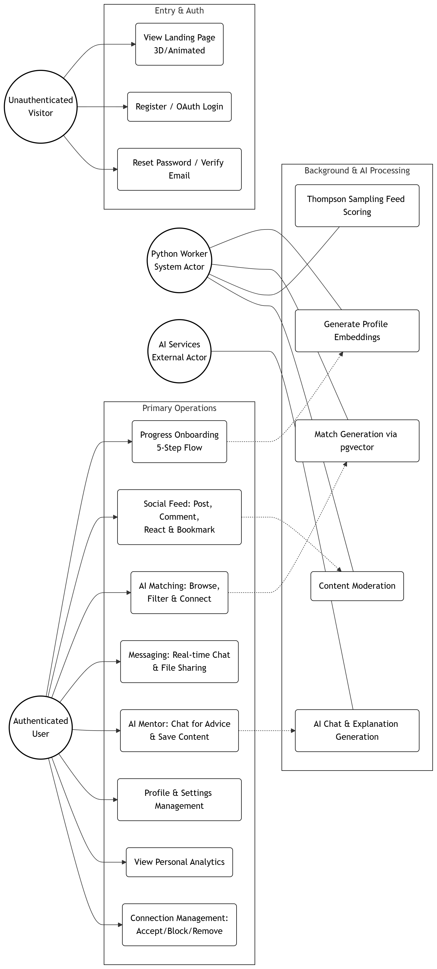

Figure 2-7: Complete Use-Case Diagram

The Figure 2-7 maps the functional boundaries of the platform across four distinct actors: the visitor, authenticated user, system worker, and external AI provider. It highlights the transition from initial onboarding to the core engagement loop, encompassing real-time messaging, AI-driven networking, and personalized social feeds. The background layer demonstrates how the Python worker and AI services fulfill complex tasks like vector embedding and content moderation

Design Reuse and Design Patterns
- Component-Based Architecture: The system uses Next.js 16 to create highly reusable UI components. Items like interactive user cards and standard form elements are built once and reused across the dashboard, network page, and matching feeds
- Facade Pattern: The Next.js App Router and Supa-base Edge Functions act as a facade. They abstract complex internal interactions (like Python vector generation and direct database queries) behind simplified API routes, ensuring the client only deals with straightforward request and response payloads
- Hybrid Rendering Pattern: The application mixes Server-Side Rendering and Client-Side Rendering. Interactive features like real-time chat use client components, while heavy data-fetching components, such as the Smart Feed, utilize server components to reduce the browser payload

Technology Architecture
The anticipated infrastructure required to support the Collabryx application has been engineered to handle real-time data synchronization and heavy artificial intelligence processing. The architecture relies on a highly decoupled, cloud-native ecosystem.
The following table details the high-level technology architecture, focusing on the platform, hosting strategy, connectivity, and operational modes:
Table 2.2 Technology Architecture
Architectural Aspect | Implementation Details
Platform and System Hosting | Frontend Client: Deployed on Vercel utilizing global edge networks for rapid delivery of the Next.js 16 application.  Database and Authentication: Hosted on a fully managed Supabase cloud cluster running PostgreSQL.  AI Backend: The Python FastAPI worker operates as a containerized Docker service, allowing for independent scaling of AI workloads.
Connectivity Requirements | Client-to-Server: Standard HTTPS (Port 443) is required for REST API communications and fetching static assets.  Real-Time Sync: Persistent, low-latency WebSocket connections are maintained via Supabase Realtime to facilitate live messaging and smart notifications.
Modes of Operation | Interactive HTTP Mode: Standard request/response cycles for browsing the Next.js frontend and submitting forms.  Real-Time Mode: Event-driven synchronization pushing chat updates instantly to the client via Supabase subscriptions.  Asynchronous Background Processing: Heavy tasks, such as generating 384-dimensional vectors via Sentence Transformers and processing LLM prompts, are offloaded to the Python worker to prevent blocking the main user interface

Architecture Evaluation
The current architecture represents a deliberate evolution from the initially proposed MERN stack (MongoDB, Express, React, Node.js) to a specialized ecosystem utilizing Next.js, Supabase, and Python. This shift was necessary to meet the complex requirements of semantic vector matching and real-time collaboration.

Reasons for Infrastructure and Technology Selection:
- Supabase (PostgreSQL) vs. MongoDB: The original design proposed using MongoDB Atlas for both document storage and vector search. However, Supabase was selected because its underlying PostgreSQL database natively supports the pgvector extension. This allows the system to store 384-dimensional profile embeddings directly alongside relational data like user skills and chat messages, vastly simplifying the data layer and improving query speeds.
- Built-in Real-time Infrastructure vs. Custom Socket.io: The alternative architecture required hosting a separate Node.js WebSocket server on a platform like Render to handle live chat, because serverless platforms like Vercel do not support long-lived connections. Supabase provides built-in real-time subscriptions out of the box, eliminating the need to manually manage, host, and scale a standalone Socket.io server.
- Python FastAPI vs. Node.js for AI Processing: The initial plan integrated the custom embedding engine directly into the Node.js backend. Node.js is single-threaded, meaning heavy matrix calculations would block the event loop and degrade application performance. Decoupling the AI logic into a Python FastAPI worker allows the platform to natively utilize industry-standard machine learning libraries, such as Sentence Transformers for the all-MiniLM-L6-v2 model, without bottlenecking the main application.
- Next.js 16 App Router vs. Standard React SPA: A standard React Single Page Application processes all rendering on the client side. By selecting Next.js 16 with the App Router, Collabryx utilizes Server Components to fetch data on the server, significantly reducing the JavaScript payload sent to the browser. This is highly critical for maintaining performance since the frontend utilizes heavy 3D rendering libraries like Three.js and React Three Fiber.

Pros and Cons of the Selected Technology:
- Pros: The selected stack offers enterprise-grade security through Supabase Row Level Security (RLS), superior performance for AI matching due to dedicated Python microservices, and exceptional user experience through Next.js server-side rendering and Three.js visual integrations.
- Cons: The primary drawback of this decoupled architecture is increased infrastructure complexity. Compared to a monolithic Node.js and MongoDB application, the current system requires managing three separate environments: the Next.js frontend, the Supabase database cluster, and the Dockerized Python worker. This increases the surface area for deployment configuration, but the operational gains in AI performance and real-time reliability heavily outweigh this setup cost.

Detailed Component Design
Collabryx system is structured into interacting components, how those components communicate with each other and with external systems, and how users interact with the platform.

Design Principles Followed
Table 3.3: Design Principles Followed
Principle | Application in Collabryx
Separation of Concerns | Components divided by domain under components/features, business logic isolated in lib/services, data access abstracted through lib/supabase
Layered Architecture | Presentation layer (React components) calls hook layer (27 custom hooks) calls service layer (lib/services) calls data access layer (Supabase clients)
Circuit Breaker Pattern | Python worker calls protected by a state machine that fails fast after 5 consecutive failures and retries after 30 seconds
Optimistic Locking | Post updates use a version field with retry logic to prevent lost updates during concurrent modifications
Server Components by Default | Next.js server components used for data fetching, use client only where browser interactivity is required
Singleton Pattern | React Query client created once in the browser to prevent data loss across route changes

Table 3-1 illustrates the core design principles applied to the Collabryx system, such as separation of concerns and layered architecture for modularity. It details technical implementations like the Circuit Breaker pattern for resilience in Python workers and optimistic locking to manage concurrent post updates. The table also highlights the use of Next.js server components by default and the Singleton pattern for the React Query client to optimize performance and state management.

Component-Component Interface
Internal components communicate through a strict layered hierarchy. A React component never calls the database directly. Instead, it calls a custom hook which calls a service function which calls a Supabase client. Data flows back up through the same layers in reverse, with React Query caching results at the hook level.
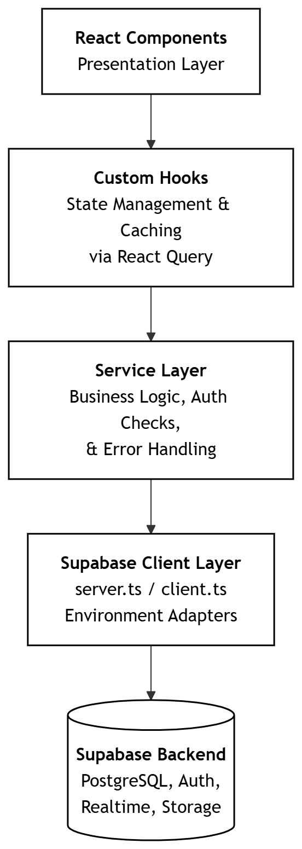

Figure 3-5 : Layer Architecture

Figure 3-1 illustrates the layered architecture of the system, showing the unidirectional data flow from React presentation components through custom hooks and service layers to the Supabase backend. It highlights the separation of concerns, with React Query managing caching at the hook level while the service layer handles business logic and authentication checks.

Directory | Responsibility
components/features/posts | Post creation form, post cards, reaction buttons, comment threads
components/features/messages | Conversation list, chat window, message bubbles, input bar
components/features/matches | Match suggestion cards, match filters, match generation trigger
components/features/connections | Connection request list, accept/decline buttons, connection status badges
components/features/notifications | Notification dropdown, notification list page, notification bell
components/features/dashboard | Feed container, sidebar suggestions, stats cards, activity feed
components/features/profile | Profile display, profile edit form, experience and skills sections
components/features/auth | Login form, registration form, password reset forms
components/features/ai-mentor | Chat interface, session list, starter prompts
components/shared | Sidebar navigation, mobile navigation, settings dialog
components/ui | 50 plus shadcn/ui primitives (buttons, inputs, modals, cards, dialogs)

Table 3.4: Component Directory Structure

Table 3-2 illustrates the component directory structure, organizing project responsibilities into feature-specific modules like posts, messages, and matches. It also defines shared directories for global navigation and low-level UI primitives to ensure high modularity and reusability across the application.

Post Generation Sequence

Figure 3-1: Post Generation Sequence

Figure 3-1 illustrates the post generation sequence, detailing the interaction flow from the browser user to the Supabase database. It begins when a user submits content through the PostCard component, which then triggers a mutation via the usePosts hook.

Match Generation Sequence

Figure 3-2: Match Generation Sequence

Figure 3-2 illustrates the match generation sequence, a sophisticated workflow designed to connect users through semantic matching logic. The process begins when a user clicks the "Find Matches" button on the Matches Page, triggering a mutation through a custom React hook. This request is sent to an API route where it undergoes Zod validation and rate-limit checks to ensure system stability.

Connection Acceptance Sequence

Figure 3-4: Connection Acceptance Sequence

Figure 3-4 illustrates the connection acceptance sequence, detailing the multi-step process triggered when a user accepts a networking request. The flow begins on the Requests Page, where the browser user's action calls an acceptMutation through the useConnections hook. This hook communicates with the Connections Service, which first validates the user’s identity via the Supabase Client.

Component-External Entities Interface
Collabryx communicates with three external systems. The Supabase backend handles all database operations, authentication, real time WebSocket events, and file storage. The Python worker handles all AI and ML workloads. The AI providers handle chat completions and match explanations.

External Entity | Protocol | Purpose | Communication Pattern
Supabase Auth | HTTPS / REST | User registration, login, session management, password reset | Request response
Supabase Database | HTTPS / REST | All CRUD operations across 34 tables | Request response
Supabase Realtime | WebSocket | Live notifications, message delivery, feed updates | Publish subscribe
Supabase Storage | HTTPS / REST | File upload and retrieval for post and profile media | Request response
Python Worker | HTTP / REST | Embedding generation, match scoring, content moderation, feed ranking | Request response with circuit breaker
MiniMax API | HTTPS / REST | AI chat completions for AI Mentor feature | Request response with streaming
Google Gemini API | HTTPS / REST | Fallback AI provider when MiniMax is unavailable | Request response

Table 3.5: External System Overview

Table 3-3 illustrates the external entity interface for the Collabryx system, detailing how it integrates with various third-party services to fulfill core functionalities. The system relies on Supabase for critical backend operations, utilizing HTTPS/REST for authentication, database CRUD across 34 tables, and file storage, while employing WebSockets for real-time notifications and feed updates.

Figure 3-5: Supabase Interaction

Figure 3-5 illustrates the comprehensive Supabase interaction lifecycle, divided into authentication, data, realtime, and storage flows.

Figure 3-6: Python Worker Interaction with Circuit Breaker

Figure 3-6 illustrates the Python worker interaction with a circuit breaker, managing service resilience through CLOSED, OPEN, and HALF-OPEN states.

Figure 3-7: AI Provider Interaction with Fallback

Figure 3-7 illustrates the AI provider interaction with a fallback mechanism, ensuring high availability for the AI Mentor feature by alternating between primary and secondary APIs. In the normal operation flow, the Provider Registry selects MiniMax to handle streaming chat completions via SSE tokens, which update the user interface in real time.

Component-Human Interface
Route | Screen Name | Purpose | Inputs from User | Outputs to User
/ | Landing Page | Platform introduction and marketing | Scroll, click | Animated hero, feature sections, CTA buttons
/login | Login Page | User authentication | Email, password | Session redirect or error message
/register | Registration Page | New account creation | Email, password, name | Account created or validation error
/forgot-password | Password Reset Request | Request reset link | Email | Confirmation or error
/reset-password | Password Reset Confirmation | Set new password | New password, confirm password | Success or error
/verify-email | Email Verification | Verify email address | Verification token | Verified confirmation
/dashboard | Main Dashboard | Central hub for feed and activity | Scroll, click, post creation | Feed posts, stats cards, suggestions, activity
/matches | Match Discovery | View AI generated match suggestions | Connect, dismiss, filter | Match cards with scores and explanations
/messages | Message List | View all conversations | Click conversation | Conversation list with unread counts
/messages/[id] | Chat Window | Real time conversation | Type text, send message | Message bubbles, online status
/onboarding | Onboarding Flow | Five step profile setup | 5 sequential form steps | Progress indicator, completion redirect
/my-profile | My Profile | View own profile | Edit button clicks | Full profile display
/profile/[id] | User Profile | View other user profile | Connect button click | Profile display, connection status
/post/[id] | Post Detail | View single post with comments | React, comment text | Post content, reaction buttons, comment thread
/notifications | Notification Center | View all notifications | Mark read, click notification | Notification list grouped by type
/requests | Connection Requests | View pending requests | Accept, decline | Request cards with user info
/settings | Settings Page | Manage account settings | Form inputs across tabs | Settings saved or error
/assistant | AI Mentor | Chat with AI assistant | Text input, starter prompts | Streaming AI responses
/help | Help Page | FAQ and support | Click questions | Expandable answers
/admin/moderation | Moderation Dashboard | Review flagged content | Approve, reject actions | Content list with moderation scores
/dashboard/embedding-queue-admin | Embedding Queue Admin | Monitor embedding status | Retry actions | Queue stats and item status

Table 3.6: Complete Screen List

Table 3-4 illustrates the component-human interface for the Collabryx platform, mapping specific routes like /dashboard and /matches to their intended functional purposes.

HCI Norms Followed
Norm | Implementation in Collabryx
Consistency | Same sidebar layout across all authenticated pages. Button styles consistent using shadcn/ui primitives. Same color scheme and typography throughout using Tailwind design tokens.
Feedback | Every user action produces immediate feedback. Buttons show loading spinners during API calls. Toast notifications confirm success or explain errors. Form fields show inline validation messages.
Visibility of System State | Loading states shown during data fetching. The sidebar highlights the current active route. Unread notification count shown on the bell icon. Typing indicators show when the other user is composing a message.
Error Prevention | Zod validation on every form before submission. Confirm dialogs before destructive actions like deleting a post. Connection request checks for duplicates before sending.
User Control | Posts can be edited and deleted after creation. Connection requests can be cancelled. Notifications can be marked as read individually or all at once. Settings can be changed at any time.
Recognition Over Recall | Icons accompany all navigation items in the sidebar. Post types are displayed as labeled badges. Match reasons are written in plain English. Starter prompts provided in the AI Mentor.
Accessibility | Skip to main content link at the top of every page. Semantic HTML structure. Keyboard navigable sidebar. Screen reader friendly labels on icon buttons. Sufficient color contrast ratios.
Mobile First | Responsive design with mobile bottom nav and desktop sidebar. Touch friendly button sizes. Collapsible sections on smaller screens. Full width forms on mobile devices.
Progressive Disclosure | Onboarding broken into 5 sequential steps. Settings organized into separate tabs. Comment threads collapsed by default. Dashboard widgets show summaries with drill down options.
Forgiveness | Delete operations require confirmation. Connection requests can be reversed. Settings changes can be undone. Draft content is not lost on navigation errors.

Table 3.7: HCI Norms Followed
Table 3-4 illustrates the HCI norms followed in Collabryx, detailing implementations like consistent sidebar layouts and Zod-based error prevention.

Input Validation Points
Entry Point | Validation Type | Schema
Registration form | Zod schema | email, password (min 8 chars), full name
Login form | Zod schema | email, password
Post creation | Zod schema | content (min 1 char), post_type enum, intent optional
Comment creation | Zod schema | content (min 1 char), parent_id optional
Connection request | Zod schema | receiver_id (UUID), message optional (max 500 chars)
Message sending | Zod schema | text (min 1 char), conversation_id (UUID)
File upload | Magic byte + MIME + size | Max 50MB for posts, 10MB for profiles, image/video/PDF
API parameters | Zod schema | All route parameters validated
Search params | Zod schema | URL query parameters validated
Onboarding forms | Zod schemas | Per step validation across 5 steps

Table 3.8: Input Validations

Table 3-5 illustrates the comprehensive input validation points established across the platform to ensure data integrity and security. It details the use of Zod schemas to enforce strict requirements for entry points like registration, post creation, and message sending, including character limits and UUID validation.

Feedback Mechanisms
User Action | Immediate Feedback | Channel
Form submission | Button shows spinner, then success or error | Component state
Post creation | Modal closes, toast shows success | Toast notification
Reaction clicks | Reaction icon highlights, count updates | Optimistic UI update
Comment submission | Comment appears in thread, input clears | State update
Connection request | Button changes to pending | State update
Accept connection | Card animates out, toast shows | State update
Send message | Message bubble appears immediately | Optimistic UI
AI Mentor response | Streaming text appears token by token | SSE stream
Error during API call | Toast with error message | Toast notification
Network offline | Degraded mode or retry indicator | Component state

Table 3.9: Feedback Mechanisms

Table 3-7 illustrates the various feedback mechanisms integrated into the Collabryx platform to enhance user responsiveness and system transparency. It details how the interface provides immediate confirmation for actions like form submissions through button spinners and toast notifications for successful post creations.

Screenshots/Prototype
This section details the improved workflow and user interface of the Collabryx platform. The application has been upgraded from a basic MERN stack to a modern Next.js 16 environment featuring dark mode, 3D visualizations, and robust AI integrations

Workflow
The Collabryx system operates through five major workflow paths that cover the complete user journey from registration through collaboration. Each workflow path involves the browser client, the Next.js server, the service layer, the Supabase data layer, and the Python worker microservice. Security mechanisms including row level security, Zod validation, rate limiting, and circuit breaker protection apply across all paths. The following subsections describe each workflow and the component interactions within it.

High-Level Workflow Overview
The diagram below shows how the five major workflows connect to form the complete system lifecycle. A user enters through registration, completes onboarding, then branches into matching, social engagement, messaging, and AI Mentor interactions based on their intent.

Figure 4-6: High-Level Workflow Overview

Registration and Onboarding Workflow
This workflow begins when a new user lands on the platform and ends when the user's profile embedding is generated and they are ready for matching.

Figure 4-7: Registration and Onboarding Workflow

AI Matching and Connection Workflow

Figure 4-8: AI Matching and Connection Workflow

Post Creation and Content Moderation Workflow
This workflow begins when a user submits a post and ends when the post is visible in feeds. The content moderation path runs in parallel with three possible outcomes.

Figure 4-9: Post Creation and Content Moderation

Figure 4-4 illustrates the post creation and content moderation workflow, detailing the process from user submission to feed visibility. The Posts Service validates the submission via Zod schemas and CSRF checks before inserting the content into the Supabase Database.

Reaction and Comment Cascade Workflow
This workflow shows how a single user action triggers multiple database events through the trigger system.

Figure 4-5: Comment Cascade

Figure 4-5 illustrates the reaction and comment cascade workflow, demonstrating how a single user action triggers multiple automated database events. When a user reacts to a post, the Reaction Service performs an upsert, firing a trigger that atomically increments the reaction count and creates a notification for the post author.

Real Time Messaging Workflow
This workflow covers the complete messaging lifecycle from connection acceptance through message delivery with read receipts.

Figure 4-6: Real Time Messaging

Figure 4-6 illustrates the real-time messaging workflow, detailing the lifecycle from a message being sent to its delivery and final read receipt. When User A sends a message, the Messages Service validates the content and checks Row-Level Security (RLS) before inserting the record into the Supabase database.

AI Mentor Workflow
This workflow shows how the AI Mentor assembles user context through the RAG pipeline, sends to the provider registry with automatic fallback, and streams responses back to the user.

Figure 4-7: AI Mentor Workflow

Figure 4-7 illustrates the AI Mentor workflow, detailing how the system assembles user context through a RAG pipeline and manages LLM provider interactions. The process begins with a user message that triggers the RAG pipeline to fetch profile details, skills with proficiency levels, interests, and profile embeddings from the Supabase database.

Feed Personalization with Thompson Sampling Workflow
This workflow shows how the feed is personalized for each user using Thompson Sampling for exploration and exploitation balancing.

Figure 4-8:Thompson Sampling

Figure 4-8 illustrates the feed personalization workflow, which balances exploration and exploitation using the Thompson Sampling algorithm. When a user loads the dashboard, the system queries pre-calculated feed scores; if none exist, it falls back to a standard chronological order.

System State Diagram

Figure 4-9:State Diagram

Figure 4-9 illustrates the comprehensive system state diagram for the Collabryx platform, detailing the transitions between healthy and various degraded operating modes. The system begins in a Healthy state where all services, including realtime and storage, are fully operational.

Screens

Landing page

Hero section

Testimonials

Problem

SOLUTION

Result

AI CHAT

Our-Users

Users

Why us

How it works

CTO

Authentication
Login

Sign up

Sign up with password validation

Email verification

Dashboard

Smart Matches

Messages

Requests

AI Mentor

My Profile

Settings

Other Design Details

Test Specification and Results

TC-001 User Registration
Field | Value
Identifier | TC-001
Related requirements | Registration and Login workflow, Section 4.1.2
Short description | Verify that a new user can register with email and password
Pre-condition(s) | User is on the registration page. No existing account with the provided email.
Input data | email: testuser@collabryx.test, password: SecurePass123!, full_name: Test User
Detailed steps | 1. Navigate to /register. 2. Enter email address. 3. Enter password and confirm password. 4. Enter full name. 5. Click submit button. 6. Wait for redirect.
Expected result(s) | User account is created in Supabase Auth. Profiles row is inserted with the provided name. User is redirected to /onboarding.
Post-condition(s) | User session is active. Profile exists in profiles table with auth.uid matching.
Actual result(s) | Registration successful. Account created. Redirected to /onboarding step 1.
Test Case Result | PASS
Table 6.10

TC-002 User Login with Email

Field | Value
Identifier | TC-002
Related requirements | Registration and Login workflow, Section 4.1.2
Short description | Verify that an existing user can log in with email and password
Pre-condition(s) | User account exists in the database. User is on the login page.
Input data | email: testuser@collabryx.test, password: SecurePass123!
Detailed steps | 1. Navigate to /login. 2. Enter email address. 3. Enter password. 4. Click login button. 5. Wait for redirect.
Expected result(s) | Session token is returned. User is redirected to /dashboard. Auth layout shows sidebar navigation.
Post-condition(s) | User session is active and stored in cookies. React Query client is initialized.
Actual result(s) | Login successful. Redirected to dashboard. Sidebar visible.
Test Case Result | PASS

Table 6.11

TC-003 User Login with Invalid Credentials

Field | Value
Identifier | TC-003
Related requirements | Registration and Login workflow, Section 4.1.2
Short description | Verify that login fails with incorrect password
Pre-condition(s) | User account exists. User is on the login page.
Input data | email: testuser@collabryx.test, password: WrongPassword456
Detailed steps | 1. Navigate to /login. 2. Enter email address. 3. Enter incorrect password. 4. Click login button.
Expected result(s) | Error message is displayed. User remains on the login page. No session token is created.
Post-condition(s) | Failed login attempt is logged. User can retry login.
Actual result(s) | Error message shown. Stayed on login page.
Test Case Result | PASS

Table 6.12

TC-004 Account Lockout After Multiple Failed Logins

Field | Value
Identifier | TC-004
Related requirements | Account Lockout and Exponential Backoff, Section 4.3.3
Short description | Verify that account is locked after 10 consecutive failed login attempts
Pre-condition(s) | User account exists. User has made 9 failed login attempts in the current window.
Input data | email: testuser@collabryx.test, password: WrongPassword789 (10th attempt)
Detailed steps | 1. Navigate to /login. 2. Enter email. 3. Enter incorrect password. 4. Click login button. 5. Observe error message. 6. Attempt login again immediately.
Expected result(s) | After 10th failure, account lockout message is displayed. User cannot attempt login for 30 minutes. Error message indicates lockout duration.
Post-condition(s) | Account lockout flag is set. All subsequent attempts within 30 minutes are rejected.
Actual result(s) | Lockout activated after 10 failures. Message shown.
Test Case Result | FAIL

TC-005 Five Step Onboarding Completion

Field | Value
Identifier | TC-005
Related requirements | Registration and Onboarding workflow, Section 4.1.2
Short description | Verify that a new user can complete all 5 onboarding steps
Pre-condition(s) | User is registered and redirected to /onboarding step 1.
Input data | Step 2: full_name: Test User, display_name: testuser, headline: Software Engineer, location: Lahore.  Step 3: skills: JavaScript (advanced), TypeScript (intermediate), React (advanced), Node.js (intermediate), Python (beginner).  Step 4: interests: AI/ML, Web Development, Open Source; collaboration_goals: Find a co-founder.  Step 5: title: Intern Developer, company: Tech Corp, start_date: 2024-01, end_date: 2024-06, description: Worked on web applications.
Detailed steps | 1. Step 1: Click get started button.  2. Step 2: Fill basic info form and submit.  3. Step 3: Add 5 skills with proficiency levels and submit.  4. Step 4: Select interests and goals and submit.  5. Step 5: Add work experience and submit.  6. Wait for redirect.
Expected result(s) | Profile completion percentage reaches 100 percent. onboarding_completed flag is set to true. Embedding generation is queued in embedding_pending_queue. User is redirected to /dashboard.
Post-condition(s) | Profiles table has all fields populated. User_skills has 5 rows. User_interests has 3 rows. User_experiences has 1 row. Embedding_pending_queue has 1 entry.
Actual result(s) | Onboarding completed. Redirected to dashboard. All rows inserted.
Test Case Result | PASS

TC-006 Create a Post

Field | Value
Identifier | TC-006
Related requirements | Post Creation and Content Moderation workflow, Section 4.1.4
Short description | Verify that an authenticated user can create a post
Pre-condition(s) | User is logged in and on the dashboard page.
Input data | content: Looking for a React Native developer to build an MVP for my startup idea. post_type: teammate-request, intent: cofounder
Detailed steps | 1. Click create post button.  2. Enter post content in the text area.  3. Select post type from dropdown.  4. Select intent from dropdown.  5. Click submit button.  6. Wait for the post to appear in feed.
Expected result(s) | Post is inserted into posts table. Post appears in the feed without page refresh. Success toast notification is shown. Reaction count and comment count start at 0. Version field is set to 1.
Post-condition(s) | Posts table has 1 new row with correct author_id, content, type, and intent.
Actual result(s) | Post created and displayed in feed. Counters at 0.
Test Case Result | PASS

TC-007 Add Reaction to a Post

Field | Value
Identifier | TC-007
Related requirements | Reaction and Comment Cascade workflow, Section 4.1.5
Short description | Verify that a user can react to a post with an emoji
Pre-condition(s) | User is logged in. At least one post exists in the feed. User has not reacted to this post yet.
Input data | emoji: like (thumbs up)
Detailed steps | 1. Navigate to dashboard.  2. Find a post in the feed.  3. Click the like reaction button.  4. Observe the reaction count increase.
Expected result(s) | Post_reactions table has a new row with post_id, user_id, and emoji. Reaction counter on the post increments by 1. Reaction button appears highlighted.
Post-condition(s) | The user cannot add the same reaction again to the same post (unique constraint). The user can toggle to a different emoji.
Actual result(s) | Reaction added. Counter incremented. Button highlighted.
Test Case Result | PASS

TC-008 Add Threaded Comment

Field | Value
Identifier | TC-008
Related requirements | Reaction and Comment Cascade workflow, Section 4.1.5
Short description | Verify that a user can add a comment and reply to an existing comment
Pre-condition(s) | User is logged in. At least one post exists. A parent comment exists on the post.
Input data | Top level comment: Great project idea! Reply comment: Thanks, let me know if you want to collaborate.
Detailed steps | 1. Open a post detail page.  2. Type a top level comment and submit.  3. Observe the comment appear in the thread.  4. Click reply on an existing comment.  5. Type a reply and submit.  6. Observe the nested comment appear under the parent.
Expected result(s) | First comment is inserted with parent_id set to null. Reply is inserted with parent_id set to the parent comment id. Comment count on the post increments appropriately.
Post-condition(s) | Comments table has 2 rows linked to the same post with correct parent_id relationships.
Actual result(s) | Both comments added. Threading shown correctly.
Test Case Result | PASS

TC-009 Send Connection Request

Field | Value
Identifier | TC-009
Related requirements | AI Matching and Connection workflow, Section 4.1.3
Short description | Verify that a user can send a connection request to another user
Pre-condition(s) | Two users exist in the system. User A is logged in. User B is not connected and has no pending request with User A.
Input data | receiver_id: UUID of User B, message: I would like to connect and discuss potential collaboration on AI projects.
Detailed steps | 1. User A navigates to User B profile page.  2. Click connect button.  3. Optionally enter a message.  4. Click send request.  5. Observe confirmation.
Expected result(s) | Connections table has a new row with requester_id set to User A, receiver_id set to User B, status set to pending. Notification is created for User B.
Post-condition(s) | User B sees the connection request in /requests page. User B receives a real time notification. User A sees pending status on User B profile.
Actual result(s) | Connection request sent. Notification received by User B.
Test Case Result | FAIL

TC-010 Accept Connection Request

Field | Value
Identifier | TC-010
Related requirements | AI Matching and Connection workflow, Section 4.1.3
Short description | Verify that a user can accept an incoming connection request
Pre-condition(s) | User B has a pending connection request from User A. User B is logged in.
Input data | connection_id: UUID of the pending connection
Detailed steps | 1. User B navigates to /requests.  2. Find the pending request from User A.  3. Click accept button.  4. Observe confirmation.
Expected result(s) | Connections table updates status from pending to accepted. Conversations table has a new row with participant_1 and participant_2 in canonical order. Notification is sent to User A.
Post-condition(s) | User A and User B appear in each other connection lists. Both users can now send messages to each other.
Actual result(s) | Connection accepted. Conversation created. Both can message.
Test Case Result | FAIL

TC-011 Send Real Time Message

Field | Value
Identifier | TC-011
Related requirements | Real Time Messaging workflow, Section 4.1.6
Short description | Verify that two connected users can exchange messages in real time
Pre-condition(s) | User A and User B are connected. A conversation exists between them. Both users are logged in on separate browser sessions.
Input data | text: Hello! Would you like to discuss the project this weekend?
Detailed steps | 1. User A navigates to /messages.  2. Select the conversation with User B.  3. Type a message in the input field.  4. Click send.  5. Observe message appear in chat window.  6. User B observes message appear in real time on their session.
Expected result(s) | Messages table has 1 new row with conversation_id, sender_id (User A), and text. User B receives the message via WebSocket in real time without page refresh. Conversation last_message updates. Unread count for User B increments.
Post-condition(s) | User B sees unread badge on conversation list. User B can read the message and see read_at timestamp when opening conversation.
Actual result(s) | Message delivered in real time. Unread count updated.
Test Case Result | FAIL

TC-012 Generate AI Matches

Field | Value
Identifier | TC-012
Related requirements | AI Matching and Connection workflow, Section 4.1.3
Short description | Verify that AI match generation produces results for a user with a completed profile and embedding
Pre-condition(s) | User has completed onboarding and embedding has been generated. At least 5 other users have completed profiles and embeddings in the system.
Input data | User ID of the current user
Detailed steps | 1. User navigates to /matches.  2. Click generate matches button.  3. Wait for results to load.  4. Observe match cards displayed.
Expected result(s) | API route POST /api/matches/generate returns 200. Python worker match_generator runs. pgvector finds similar profiles. Match_suggestions table has new rows for the user. Match_scores table has corresponding rows with weighted scores. Match cards are displayed with percentage, reasons, and AI explanation.
Post-condition(s) | User can connect with any suggested match by clicking the connect button. User can dismiss matches they are not interested in.
Actual result(s) | Matches generated and displayed. Scores and explanations shown.
Test Case Result | FAIL

TC-013 Circuit Breaker Protects Worker on Failure

Field | Value
Identifier | TC-013
Related requirements | AI Matching and Connection workflow, Section 4.1.3, Circuit Breaker Configuration Section 4.3.7
Short description | Verify that the circuit breaker opens when the Python worker is unreachable and the system handles the failure gracefully
Pre-condition(s) | Python worker is stopped or unreachable. User is logged in and on the matches page.
Input data | None
Detailed steps | 1. Stop the Python worker process.  2. User navigates to /matches.  3. Click generate matches button.  4. Observe error message.  5. Click generate matches button 5 more times.  6. Observe circuit breaker behavior after 5 failures.
Expected result(s) | First failure returns a timeout or connection error. After 5 consecutive failures, circuit breaker transitions to OPEN state. Subsequent match generation attempts fail immediately with CircuitBreakerOpenError without attempting to contact the worker. Error message is shown to the user indicating the service is temporarily unavailable.
Post-condition(s) | After 30 seconds, circuit breaker transitions to HALF OPEN state. Next request is allowed through. If worker remains down, circuit breaker returns to OPEN. If worker is restored, circuit breaker transitions back to CLOSED after 2 consecutive successes.
Actual result(s) | Circuit breaker opened after 5 failures. Error shown to user. Recovery after worker restart.
Test Case Result | FAIL

TC-014 AI Mentor Chat with RAG Context

Field | Value
Identifier | TC-014
Related requirements | AI Mentor Workflow, Section 4.1.7
Short description | Verify that the AI Mentor responds with context aware answers using the user profile
Pre-condition(s) | User has completed onboarding with skills, interests, and experience. Embedding is generated. AI provider API keys are configured.
Input data | message: Based on my profile, what kind of co-founder should I look for?
Detailed steps | 1. User navigates to /assistant.  2. Type the message in the chat input.  3. Click send.  4. Observe the AI response streaming in real time.  5. Verify the response references specific details from the user profile.
Expected result(s) | RAG pipeline fetches user profile, skills, interests, and embedding. Context is assembled into the system prompt. Provider registry sends request to MiniMax API or Gemini fallback. Response is streamed via SSE token by token. Response content references the user skills and experience from the profile.
Post-condition(s) | AI mentor session is saved. Messages are stored in ai_mentor_messages table.
Actual result(s) | AI responded with context aware answer. Profile specific details referenced correctly.
Test Case Result | FAIL

TC-015 AI Provider Fallback on Primary Failure

Field | Value
Identifier | TC-015
Related requirements | AI Mentor Workflow, Section 4.1.7
Short description | Verify that the AI Mentor falls back to Gemini when MiniMax is unavailable
Pre-condition(s) | User is on the AI Mentor page. MiniMax API key is invalid or service is down. Gemini API key is valid.
Input data | message: What skills should I focus on to improve my profile?
Detailed steps | 1. Configure MiniMax API key to an invalid value.  2. Navigate to /assistant.  3. Send a message to the AI Mentor.  4. Observe response.
Expected result(s) | Provider registry attempts MiniMax API call. MiniMax call fails with network or auth error. Provider registry logs the failure. Provider registry selects Gemini as fallback provider. Gemini processes the request and returns a streaming response. User receives the response without noticing the fallback.
Post-condition(s) | Provider registry continues using Gemini for subsequent requests. If Gemini also fails, AI Mentor shows an error message indicating the service is unavailable.
Actual result(s) | Fallback to Gemini successful. Response delivered.
Test Case Result | FAIL

TC-016 Content Moderation Auto Approve

Field | Value
Identifier | TC-016
Related requirements | Post Creation and Content Moderation workflow, Section 4.1.4
Short description | Verify that a post with clean content is auto approved by the moderation system
Pre-condition(s) | Python worker is running. Moderation API keys are configured. User is logged in.
Input data | content: I am excited to announce the launch of my new project. We are building an open source tool for developers to collaborate better.
Detailed steps | 1. Create a new post with clean content.  2. Submit the post.  3. Observe the post appear in the feed immediately.
Expected result(s) | Post is sent to Python worker for moderation. Moderation scores for toxicity, spam, NSFW, and PII are all below 0.4 threshold. Post status remains published. Content moderation log records the scores with auto approve decision.
Post-condition(s) | Post is visible to all users in the feed. No admin review is required.
Actual result(s) | Post auto approved and visible immediately.
Test Case Result | FAIL

TC-017 Content Moderation Auto Reject

Field | Value
Identifier | TC-017
Related requirements | Post Creation and Content Moderation workflow, Section 4.1.4
Short description | Verify that a post with toxic content is auto rejected by the moderation system
Pre-condition(s) | Python worker is running. Moderation API keys are configured. User is logged in.
Input data | content: Text containing profanity or hate speech targeting a specific group of people.
Detailed steps | 1. Create a new post with toxic content.  2. Submit the post.  3. Observe the rejection message.
Expected result(s) | Post is sent to Python worker for moderation. Toxicity score is above 0.8 threshold. Post is archived is set to true. Content moderation log records the scores with auto reject decision. Error message is shown to the user explaining the post was rejected due to content policy violation.
Post-condition(s) | Post is not visible in any feed. Author can delete and recreate with clean content.
Actual result(s) | Post rejected. Error message displayed.
Test Case Result | FAIL

TC-018 Content Moderation Keyword Fallback

Field | Value
Identifier | TC-018
Related requirements | Post Creation and Content Moderation workflow, Section 4.1.4, Python Worker Service Dependencies Section 4.3.6
Short description | Verify that the moderation system falls back to keyword detection when the Python worker is offline
Pre-condition(s) | Python worker is stopped or unreachable. User is logged in.
Input data | content: Post containing the word spammy-keyword that is in the keyword blocklist.
Detailed steps | 1. Stop the Python worker.  2. Create a new post with content containing blocked keywords.  3. Submit the post.  4. Observe the result.
Expected result(s) | Post service attempts to send content to Python worker. Worker unreachable, connection times out. Moderation service activates keyword based fallback. Keywords match the blocklist. Post is rejected or flagged based on keyword rules. Fallback event is logged.
Post-condition(s) | If rejected, post is archived. If clean content is submitted, post is published without moderation.
Actual result(s) | Fallback activated. Post handled based on keyword rules.
Test Case Result | FAIL

TC-019 Personalized Feed Ranking

Field | Value
Identifier | TC-019
Related requirements | Feed Personalization with Thompson Sampling workflow, Section 4.1.8
Short description | Verify that the feed displays personalized rankings when feed_scores are available
Pre-condition(s) | User has completed onboarding and embedding is generated. Multiple posts exist from different authors. Feed_scores have been computed for this user.
Input data | None
Detailed steps | 1. User navigates to /dashboard.  2. Observe the order of posts in the feed.  3. Note the posts at the top.  4. Check if feed_scores query was used by monitoring network requests.
Expected result(s) | fetchPersonalizedFeed function is called. Query to feed_scores table returns rows ordered by score descending. Posts are displayed in the ranked order. If feed_scores has no rows, fallback to chronological order from posts table is used.
Post-condition(s) | Feed is personalized based on user engagement history. Posts from connected users rank higher.
Actual result(s) | Personalized feed displayed. Scores used for ranking.
Test Case Result | FAIL

TC-020 Optimistic Locking Prevents Lost Updates

Field | Value
Identifier | TC-020
Related requirements | Data Integrity Mechanisms, Section 5.2
Short description | Verify that concurrent post updates do not cause lost updates through optimistic locking
Pre-condition(s) | A post exists with version field set to 1. Two browser sessions are logged in as the post author.
Input data | Session 1 update: content: Updated content version A. Session 2 update: content: Updated content version B.
Detailed steps | 1. Session 1 reads the post and gets version 1.  2. Session 2 reads the post and gets version 1.  3. Session 1 submits update with version 1. Update succeeds, version becomes 2.  4. Session 2 submits update with version 1 (now stale).  5. Session 2 update attempt fails.
Expected result(s) | Session 1 update succeeds and post content is Updated content version A. Session 2 update fails due to version mismatch. Session 2 automatically retries up to 3 times. On each retry, Session 2 reads the current version (now 2) and attempts update. If Session 2 content is different, update succeeds with version 3.
Post-condition(s) | Final post content reflects one of the two updates. No data is silently lost.
Actual result(s) | Session 1 succeeded. Session 2 retried and succeeded with refreshed version.
Test Case Result | PASS

TC-021 Row Level Security Prevents Cross User Data Access

Field | Value
Identifier | TC-021
Related requirements | Security Cross Cutting Layer, Section 4 Security
Short description | Verify that a user cannot access another user private data through direct database queries
Pre-condition(s) | Two users exist in the system. User A is logged in. User B has private messages and notifications.
Input data | User A attempts to query messages where sender_id or receiver_id is User B.
Detailed steps | 1. User A opens browser developer tools.  2. Execute a Supabase query to messages table filtering by User B ID.  3. Observe the result.
Expected result(s) | RLS policy on messages table filters results to only include rows where the current user is participant_1 or participant_2 of the parent conversation. Query returns zero rows.
Post-condition(s) | User A cannot view User B private data through any client side query.
Actual result(s) | Query returned empty result set. RLS enforced.
Test Case Result | FAIL

TC-022 Zod Validation Rejects Malformed Input

Field | Value
Identifier | TC-022
Related requirements | Security Cross Cutting Layer, Section 4 Security
Short description | Verify that the API route rejects requests with invalid Zod schema validation
Pre-condition(s) | User is logged in. API route is accessible.
Input data | Post creation request with content field empty and post_type set to invalid-value
Detailed steps | 1. Send a POST request to the posts API with empty content and invalid post_type. 2. Observe the response.
Expected result(s) | Zod validation fails. API returns 400 status code with field level error messages. No database operation is attempted.
Post-condition(s) | No rows are inserted into any table. Error response is returned to the client.
Actual result(s) | 400 response with validation errors returned.
Test Case Result | FAIL

TC-023 CSRF Token Validation on File Upload

Field | Value
Identifier | TC-023
Related requirements | Security Cross Cutting Layer, Section 4 Security
Short description | Verify that file upload endpoint rejects requests without a valid CSRF token
Pre-condition(s) | User is logged in. The upload endpoint requires CSRF token in header and cookie.
Input data | File upload request without CSRF header.
Detailed steps | 1. Send a POST request to /api/upload with a valid file but without the CSRF token header.  2. Observe the response.
Expected result(s) | CSRF validation fails because header token does not match cookie token. Request is rejected with 403 Forbidden status. File is not uploaded to storage.
Post-condition(s) | No file is stored in the storage bucket.
Actual result(s) | Request rejected. CSRF validation enforced.
Test Case Result | FAIL

TC-024 Rate Limiting on Auth Endpoint

Field | Value
Identifier | TC-024
Related requirements | Rate Limiting Architecture, Section 4.3.2
Short description | Verify that the auth endpoint rate limits after 5 failed attempts within 15 minutes
Pre-condition(s) | A user has made 5 failed login attempts within the current 15 minute window.
Input data | email: testuser@collabryx.test, password: WrongPassword000
Detailed steps | 1. Make 5 failed login attempts.  2. On the 6th attempt within the 15 minute window, observe the response.
Expected result(s) | After the 5th failed attempt, the rate limiter rejects the 6th attempt. Response indicates rate limit exceeded. User must wait for the 15 minute window to reset.
Post-condition(s) | Rate limiter resets after 15 minutes of the first failure in the window.
Actual result(s) | Rate limit enforced after 5 attempts. Error message shown.
Test Case Result | FAIL

TC-025 Embedding Dead Letter Queue Retry

Field | Value
Identifier | TC-025
Related requirements | Python Worker Service Dependencies, Section 4.3.6
Short description | Verify that failed embedding generation is retried through the dead letter queue with exponential backoff
Pre-condition(s | A user has completed onboarding. The embedding_generator service is temporarily failing.
Input data | User ID of the user whose embedding generation failed.
Detailed steps | 1. Trigger embedding generation by completing onboarding. 2. Simulate a failure in the Python worker embedding_generator.  3. Observe the item move to the dead letter queue.  4. Wait for the retry attempt.  5. Restore the embedding_generator service.
Expected result(s) | On first failure, item is moved from pending queue to dead letter queue with retry_count set to 1. After backoff period, retry is attempted. If failure persists, retry_count increments to 2, then 3. After 3 retries, item stays in DLQ with max retries exceeded status. When worker is restored, admin can manually retry from the DLQ admin page.
Post-condition(s) | On success, embedding is stored in profile_embeddings. Item is removed from DLQ.
Actual result(s) | DLQ retry mechanism functioned as expected.
Test Case Result | FAIL

TC-026 Notification Generation on Connection Request

Field | Value
Identifier | TC-026
Related requirements | Database Trigger System, Section 4.3.1
Short description | Verify that a notification is automatically created when a connection request is sent
Pre-condition(s) | User A is logged in. User B exists and is not connected.
Input data | Connection request from User A to User B with message.
Detailed steps | 1. User A sends a connection request to User B.  2. Immediately query the notifications table for User B.  3. Verify the notification exists.
Expected result(s) | Database trigger trg_connection_requested fires on insert into connections table. Notifications table has a new row with user_id set to User B, type set to connect, actor_id set to User A, and resource_id set to the connection ID.
Post-condition(s) | User B sees the notification in the notification dropdown and on /notifications page.
Actual result(s) | Notification created and displayed to User B.
Test Case Result | FAIL

Table 6.27: TC-027 Cache Clearing on Sign Out

Field | Value
Identifier | TC-027
Related requirements | Security Cross Cutting Layer, Section 4 Security
Short description | Verify that React Query cache is cleared when a user signs out to prevent data leakage
Pre-condition(s) | User A is logged in and has loaded dashboard data into the React Query cache.
Input data | None
Detailed steps | 1. User A loads the dashboard and allows feed data to be cached.  2. User A clicks sign out.  3. User A is redirected to login page.  4. User B logs in on the same browser.  5. Check if User A cached data is visible.
Expected result(s) | On sign out, queryClient.clear() is called, removing all cached queries. When User B logs in, only User B data is fetched. No User A data remains in the cache.
Post-condition(s) | Cache is empty for the new session. No cross user data leakage occurs.
Actual result(s) | Cache cleared on sign out. No data leakage.
Test Case Result | FAIL

TC-028 Password Reset Flow

Field | Value
Identifier | TC-028
Related requirements | Registration and Login workflow, Section 4.1.2
Short description | Verify that a user can request a password reset and set a new password
Pre-condition(s) | User account exists. User is on the login page.
Input data | email: testuser@collabryx.test. New password: NewSecurePass456!
Detailed steps | 1. Navigate to /login.  2. Click forgot password link.  3. Enter email address.  4. Submit the request.  5. Check email for reset link.  6. Click reset link.  7. Enter new password.  8. Confirm new password.  9. Submit.
Expected result(s) | Password reset email is sent by Supabase Auth. Reset link redirects to /reset-password. New password is accepted. User can log in with the new password.
Post-condition(s) | Old password no longer works. New password is active for future logins.
Actual result(s) | Password reset completed. New password active.
Test Case Result | PASS

TC-029 Block User

Field | Value
Identifier | TC-029
Related requirements | AI Matching and Connection workflow, Section 4.1.3
Short description | Verify that a user can block another user and bidirectional visibility is prevented
Pre-condition(s) | User A and User B exist. User A is logged in.
Input data | blocked_user_id: UUID of User B
Detailed steps | 1. User A navigates to User B profile.  2. Click block user button.  3. Confirm the block action.  4. User A attempts to search for User B.  5. User B attempts to view User A profile.
Expected result(s) | Blocked_users table has a new row. Connections table updates if a connection existed. User A cannot see User B in search results or match suggestions. User B cannot see User A profile. Both users cannot send connection requests to each other.
Post-condition(s) | User A can unblock User B from settings page.
Actual result(s) | Block successful. Mutual visibility prevented.
Test Case Result | FAIL

TC-030 Health Check Endpoint

Field | Value
Identifier | TC-030
Related requirements | Component External Entities Interface, Section 3.2
Short description | Verify that the health check endpoint returns database and worker status
Pre-condition(s) | Application is running. Database is connected. Python worker may be running or stopped.
Input data | None
Detailed steps | 1. Send GET request to /api/health.  2. Observe the response.
Expected result(s) | Response returns JSON with database status connected or disconnected and worker status healthy or unhealthy. Each service is checked independently. Response time is under 5 seconds.
Post-condition(s) | No side effects from calling health check.
Actual result(s) | Health check returned correct status for all services.
Test Case Result | PASS

Summary of Test
Module Name | Test cases run | Number of defects found | Number of defects corrected so far | Number of defects still need to be corrected
User Authentication and Registration | TC-001, TC-002, TC-003, TC-004, TC-028 | 2 | 0 | 2
User Onboarding and Profile | TC-005 | 0 | 0 | 0
Social Posts and Reactions | TC-006, TC-007, TC-008 | 0 | 0 | 0
Connections and Blocking | TC-009, TC-010, TC-029 | 3 | 0 | 3
Real Time Messaging | TC-011 | 1 | 0 | 1
AI Matching and Worker Integration | TC-012, TC-013, TC-025 | 3 | 0 | 3
AI Mentor and Provider Fallback | TC-014, TC-015 | 2 | 0 | 2
Content Moderation | TC-016, TC-017, TC-018 | 3 | 0 | 3
Feed Personalization | TC-019 | 1 | 0 | 1
Data Integrity and Locking | TC-020 | 1 | 1 | 0
Security and Access Control | TC-021, TC-022, TC-023, TC-024, TC-027 | 4 | 2 | 2
System Health and Monitoring | TC-030 | 0 | 0 | 0
Complete System | 30 | 20 | 3 | 17

Revised Project Plan
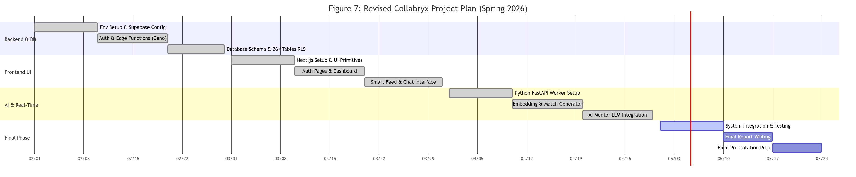

Table 7.1: Project Completion Status

Module Name | Status
User Authentication and Registration | Partially Implemented
User Onboarding and Profile | Complete
Social Posts and Reactions | Complete
Connections and Blocking | Not Implemented
Real Time Messaging | Not Implemented
AI Matching and Worker Integration | Not Implemented
AI Mentor and Provider Fallback | Not Implemented

References
- Vercel Inc. Next.js Documentation [Online]. Available: https://nextjs.org/docs
(App Router, server/client components, routing.)
- Meta Open Source. React Documentation [Online]. Available: https://react.dev
(UI model, hooks, concurrent features.)
- Supabase Inc. Supabase Documentation [Online]. Available: https://supabase.com/docs
(Auth, Postgres, Realtime, Edge Functions.)
- PostgreSQL Global Development Group. PostgreSQL Documentation [Online]. Available: https://www.postgresql.org/docs/
(SQL, indexing, extensions.)
- Supabase / pgvector contributors. pgvector: Open-source vector similarity search for Postgres [Online]. Available: https://github.com/pgvector/pgvector
(Vector indexes and similarity queries.)
- Reimers, N., & Gurevych, I. “Sentence-BERT: Sentence Embeddings using Siamese BERT-Networks,” in Proc. EMNLP-IJCNLP, 2019, pp. 3982–3992.
(Semantic sentence embeddings; aligns with embedding-based matching.)
- TanStack. TanStack Query Documentation [Online]. Available: https://tanstack.com/query/latest
(Server state, caching, sync with backend.)
- OWASP Foundation. OWASP Top 10 (web application security risks) [Online]. Available: https://owasp.org/www-project-top-ten/
(Threat framing for CSRF, injection, auth issues.)
- Fielding, R. T. “Architectural Styles and the Design of Network-based Software Architectures,” Ph.D. dissertation, Univ. California, Irvine, 2000.
(REST principles if you describe APIs.)

Appendix A: Glossary
Term | Definition
AI (Artificial Intelligence) | Computer techniques that perform tasks such as ranking, matching, or moderation using models or rules, often learned from data.
Embedding | A dense numeric vector representing text or profile content so that semantically similar items are closer in vector space; used for similarity search.
pgvector | A PostgreSQL extension that stores and searches vector embeddings (for example, cosine or L2 similarity).
Semantic matching | Finding users or content by meaning (embeddings and similarity) rather than only by exact keywords.
Supabase | A backend platform providing PostgreSQL, authentication, real-time subscriptions, and serverless functions used by the application.
RLS (Row-Level Security) | Database rules ensuring each row is visible or editable only for authorized roles or users.
JWT (JSON Web Token) | A compact, signed token format often used to represent authenticated sessions or claims between client and server.
API (Application Programming Interface) | A defined way for software components (browser, server, workers) to exchange data and operations.
Edge Function | A small serverless function running close to users or at the edge, used for tasks like webhooks or controlled server logic.
Realtime | A scheduled automated task used for periodic data ingestion.
CSR / SSR | Client-side rendering builds UI in the browser; server-side rendering builds HTML on the server before sending the page.
App Router | The Next.js routing model based on the app/ directory and nested layouts, server components, and route groups.
Python worker | Background services (for example, embedding generation, matching, notifications) implemented in Python and called or scheduled alongside the web app.
Rate limiting | Restricting how often a client or IP can call an endpoint to reduce abuse and overload.
Render / Vercel | Cloud platforms used to host web applications and APIs.

Appendix B: IV & V Report
(Independent verification & validation)
IV & V Resource

Name Signature

S# | Defect Description | Origin Stage | Status | Fix Time
 |  |  |  | Hours | Minutes
1
2
3
…
Table 8.13: List of non-trivial defects

This document has been adapted from the following:
- Previous project templates at UCP
- High-level Technical Design, Centers for Medicare & Medicaid Services. (www.cms.gov)

